**United States Healthcare Insurance System**

Nowadays, is not any doubt about that people’s health has a very highly risk, contemplating the COVID-19. Aside of this, is ordinary to see that the frequency of health problems across our life have a tendency to increase, but at the same time our preoccupation to take decisions about how to take actions in a possible scenario begin to surge. Therefore in 1850 in Massachusetts Franklin Health Assurance Company see a market opportunity, by selling insurance plans against accidents. So, the business started to grow quickly, just by remaking a very interesting fact according to HIAA (1997), that “sixty organizations were offering accident insurance in the US by 1866” and then is 1890 surged the sickness coverage insurance services.

Like any profitable industry, if it starts growing the demand will increase, so many companies will begin to have highest operation costs and capital expenses, and with this comes the pursuit to get higher earnings margin, by increasing prices.

**Coverage across the country**

To analyze the situation of this country is important to know what we just mentioned to conclude, what is happening, as simple to say that for too many people, obtain an insurance plan is practically inaccessible. Fortunately, on March 23 of 2010, the president Barack Obama recognized the law of Patient Protection and Affordable Care Act, and with this the program of Affordable Care Act (ACA). This covers multiple provisions that brought down the uninsured population from 50 million to 27 million, by increasing assistances and lowering costs, inclusively provide new funding for public health and prevention according to HealthCare.gov.

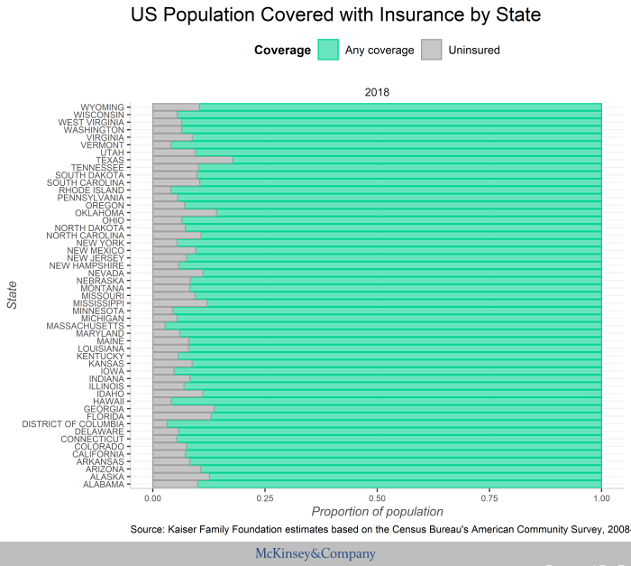

Taking a quick insight about the insurance coverage in the United States we can see that considering the 320 million people that lives in the US there are states that reach nearly 20% of population uninsured by healthcare plans. Agreeing to The Henry J. Kaiser Family Foundation (2020), in their last state indicator of 2018, is undoubtedly to say for the richest states like California and New York, there are more covered people, considering the huge job opportunities and all the people that can get insurance plans by Employer-based, TRICARE or by the most expensive way, directly.

To be clearer let’s see the next graphic retrieved from the Kaiser Family Foundation National Report of 2015.

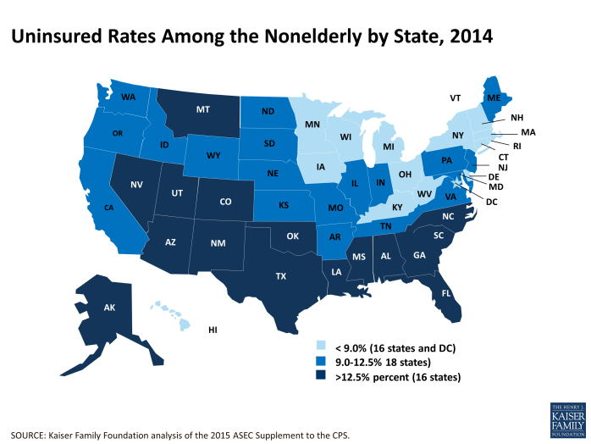

As said before the most consolidated, economically, states are those brighter ones and the other ones with less covered people has rate over 12.5% of their population uninsured, note the darker ones.

To be more specific we will analyze the behavior for each state. The main variable to focus on is the age of the habitant, for the reason we classify the uninsured population is because one of the main reasons people can’t get insurance plans is due their medical history. So, we classify it by people between 0 to 18 years, and those who has from 19 to 65 years old.

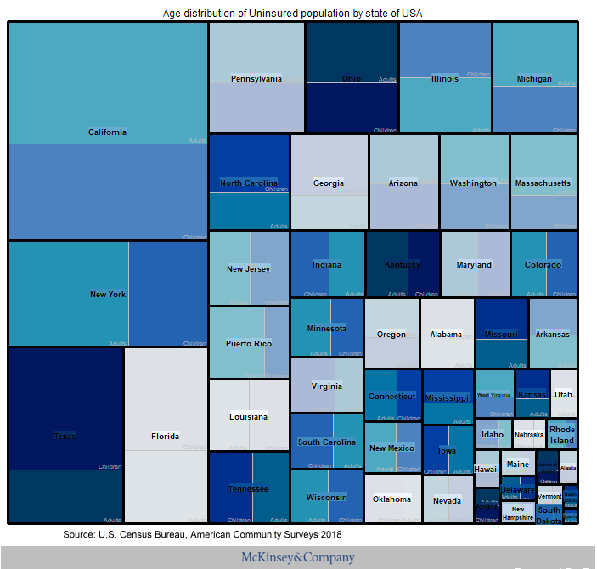

In this Tree Map we can see that, taking the example of New York, that is a “workers-crownded” state, the biggest proportion of uninsured persons are adults, and ¿What is the reason? The main reason is the same that ACA is battling with, the rejection of insurance plan’s requests due preexisting health conditions, clearly more evident on elderly people.

**Economic Summary**

Considering the government side of this situation, the State plays a very important role, by letting public insurance corporations help the people with programs like Medicaid or Medicare. The first one covers people over 65 years old and young people with patology difficulties or other types of disabbilities; the second one covers people with extremely low incomes or in condition of poverty. Also there is the S-CHIP program that covers people with earnings over the limit of Medicaid but don’t have enough to pay private insurance, and others like VA for veterans. It’s important to say that the present Republican Government don’t support at all this corporations neither the ACA.

With the most recent global pandemic issues President Donald Trump has decided not to reopen the markets of Obamacare despite broad layoffs and growing fears that people will be uninsured. The reason of this, he explained it by saying that all is to protect these corpotions’s economy by blocking people that want to take advantage of the insurance services provided, because considering the unestable scope of this situation, this corporations can lead to the bankruptcy, according to the New York Times (2020).



Perhaps all this controversy by the last graph about expenditures we can see that, by the projected line of increase by the year 2028, the government will be spending around $18,000 by habitant in insurance coverage and a Residual Expenditure (entire quantity of healthcare services spending with all possible margin of errors) of $10,000 billions of dollars in an entire year.

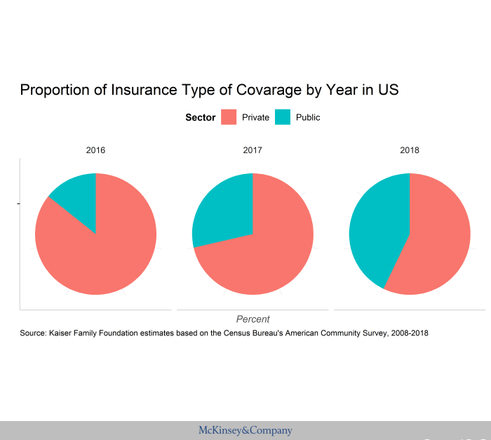

The good role of this public programs gave results, as we can see the proportion of users of Public Insurance are increasing thanks to laws like fiscal fines for staying out of coverage in working environments, subsidy in adquirement of insurance plans and limiting the rising of prices. In other words the HHS (Office of Health and Human Sevices) has done a great job.

**Users by Insurance Type**

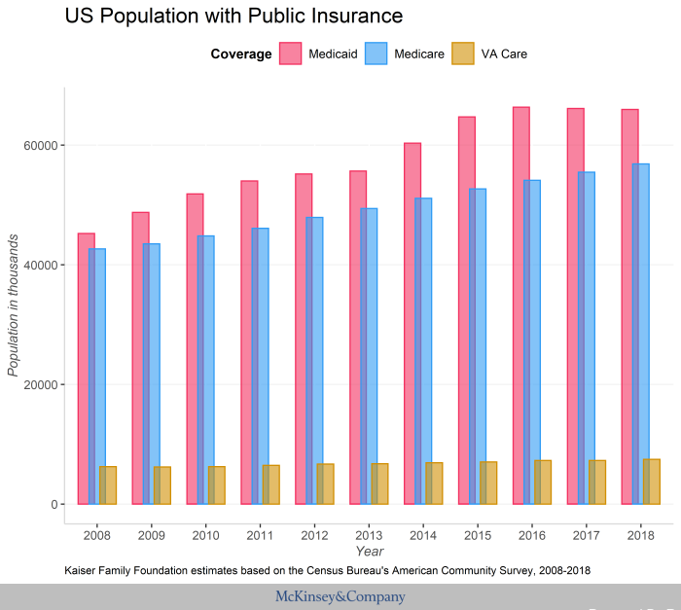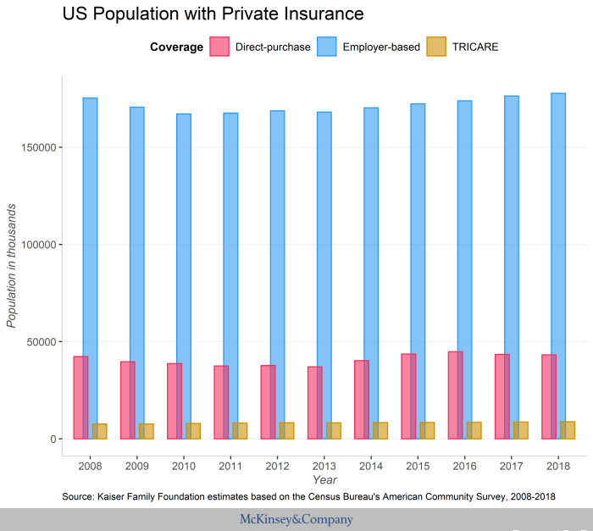

**Private Insurance Situation**

In the other side of the coin Private Corporation like Anthem Inc, Centene Corporation, Cigna, Humana or UnitedHealth, has taken actions due the global crisis. The main reason was the rise of the Pandemic Risk Insurance Act, after the Government stablish it in a not clearly way to low the adquisition cost due the broad layoffs. This because all the people that had an employer-direct insurance and were sacked, now could have some difficulties to get a new one.

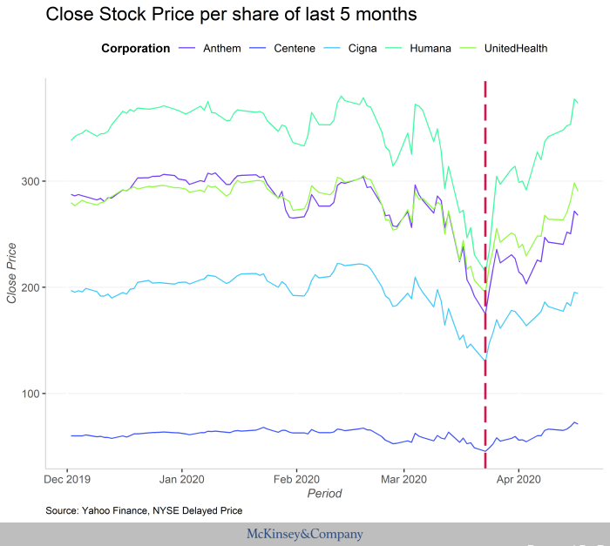

Also the situation about reject the “reimburse of telemedicine” make these corporations lose a lot of clients according to The Guardian (2020), and by the way lead a huge drop in the stock market at the last days of March (Showed in the last graph). Because of this they are rising again by offering to waive co-pays for all diagnostic testing related to COVID-19, according to CVS Health. That includes all member costs associated with diagnostic testing for Commercial, Medicare, and Medicaid lines. And of course, zero co-pay telemedicine visits for any reason, and it is extending its Medicare Advantage virtual, and also people diagnosed with COVID-19 will receive a care package.

**Conclusions**

Right now, the priority is to survive this global pandemic but by the way, like the Republicans said, they can’t let the economy ruined. So here is one important matter, and it is to work all together, specially the healthcare services.

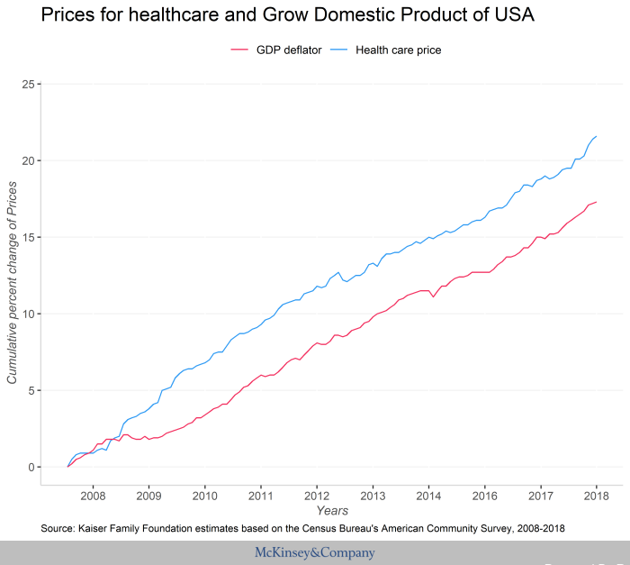

Seeing this timeline, the price of healthcare services has a clearly greater trending to grow than the Grow Domestic Product of the United States, and this leaves too much to think about. Because inclusively in times of crisis, where people need help, the health will be always seen like a wealthy business.

Finally, here is a summary graph about the estimated COVID-19 treatment prices for public-insured, private-insured and non-insured customers retrieved from The Business Insider.

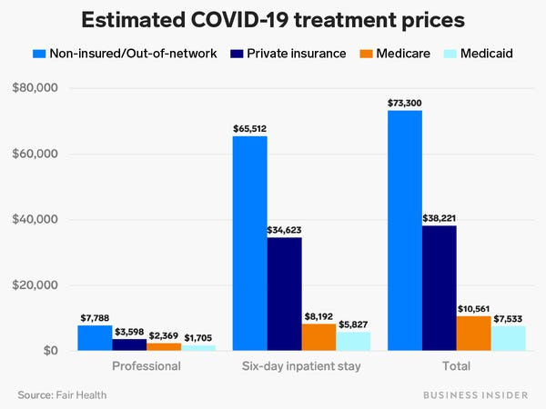

**More Information at**

"Health insurance that counts as coverage". HealthCare.gov.

HIAA Insurance Education (1997). Fundamentals of health insurance, Part A. Washington, D.C.: Health Insurance Association of America.

Obamacare Markets Will Not Reopen, Trump Decides. Nytimes.com. (2020). Retrieved 21 April 2020, from https://www.nytimes.com/2020/04/01/upshot/obamacare-markets-coronavirus-trump.html.

Rao, A. (2020). US private health insurance companies clog system amid Covid-19 pandemic. the Guardian. Retrieved 21 April 2020, from <https://www.theguardian.com/us-news/2020/mar/26/us-insurance-companies-coronavirus-hospitals>.

Uninsured Rates. The Henry J. Kaiser Family Foundation. (2020). Retrieved 21 April 2020, from [https://www.kff.org/uninsured/state-indicator/rate-by-age/?currentTimeframe=0&sortModel=%7B%22colId%22:%22Location%22,%22sort%22:%2](https://www.kff.org/uninsured/state-indicator/rate-by-age/?currentTimeframe=0&sortModel=%7B%22colId%22:%22Location%22,%22sort%22:%252).

*Append*: this report was made in R Markdown file only for evidence of knowledge during job recruitment for “Junior Research Analyst” - Healthcare Systems & Services position.

Sincerely, Roberto Andrés Aguilar Quesada.

To get more information about the code visit my GitHub repository at: <https://github.com/Razerhawk>, <*Insights Factory* *Healthcare_insurance_Research*>.